MUSE: Machine enhanced User Sound Experience User Research Report

1. Overview
MUSE is a concept for an audio mixing tool designed to make sound enhancement simple and accessible. The tool would allow users to upload an audio file and adjust elements such as vocals, instrumentals, or background layers. The goal of this study is to understand user expectations, control preferences, and potential use cases for MUSE based on early interface mockups. This research represents a formative evaluation of early design concepts for MUSE. Insights from this study will inform interface design choices and user-centered requirements before the development of a functional prototype.

2. Research Questions
The study was guided by the following research questions:
- How do potential users currently interact with or edit audio content, if it all?
- What level of familiarity do users have with existing audio editing or mixing tools?
- Which interface design (horizontal sliders, vertical sliders, or knobs) appears most intuitive to users?
- What types of controls or feedback do users expect in an audio enhancement tool?
- What potential applications or contexts do users envision for a tool like MUSE?
- In what situations or contexts would users find a tool like MUSE most useful?

3. Method
This study used an interview method. We interviewed three participants in person, one-on-one, and then collected supplemental data via Google Forms for downstream prototyping. The survey collected both quantitative and qualitative feedback on users’ preferences and experiences.

3.1 Participants

Participants were chosen based on who we know. Specifically, within our labs (for the PhD students) or students within our batches (Masters).
Participants were asked to indicate their academic or professional status, gender identity, and any hearing-related sensitivities or assistive technology use. This information will help contextualize responses and understand accessibility considerations.

3.2 Materials
Participants viewed three static wireframe mockups. We chose these three input formats because they are the most common when it comes to adjusting levels of input. Each wireframe is an interactable HTML script:
- Wireframe 1: Horizontal sliders
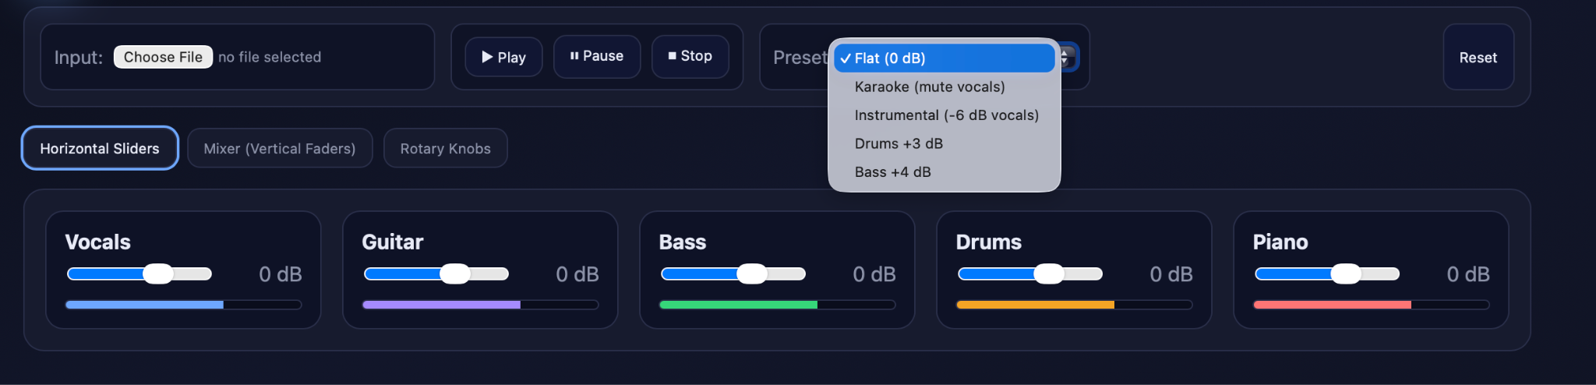
- Wireframe 2: Vertical sliders
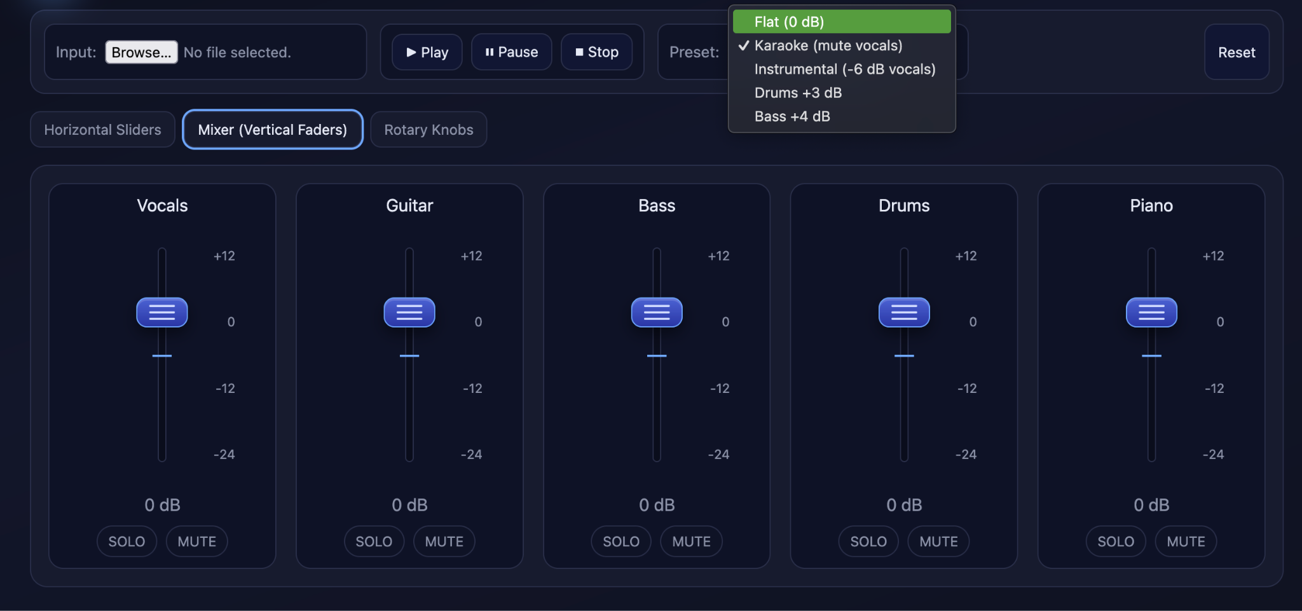
- Wireframe 3: Rotary knobs
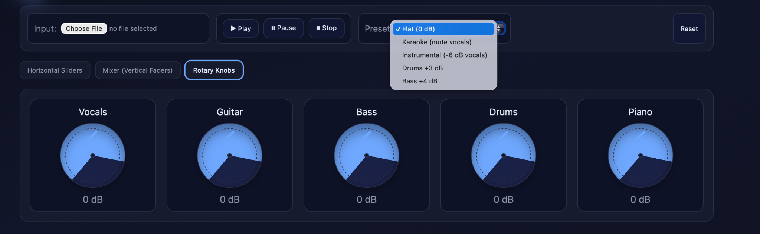
These mockups represented potential interface layouts for controlling different elements of an audio mix.

3.3 Procedure
Participants answered questions about:
- Prior experience with audio or mixing software
Frequency of working with or listening to multi-instrument recordings (e.g., songs, orchestral pieces, podcasts, or film audio)
- Preference for one of the three mockup designs
- Open-ended feedback explaining their choice and suggesting improvements
Responses were anonymous and collected via in-person interviews and supplementally online via Google Forms. Each interview lasted approximately 15 minutes and followed a set of questions. All responses were stored anonymously using Google Forms for simplifying analysis.
Google Form: https://docs.google.com/forms/d/e/1FAIpQLSfi3kDm8sMecVQP7Me-tOAwdRUypPrpCZT-WAfrevV3j5cXug/viewform

4. Results

For visualization purposes, we are including both our in-person and online responses, anonymized. Without it, the visualizations don’t show much valuable information.

4.1 Demographics
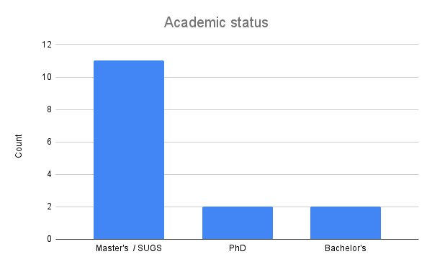
A majority of our interviewees and online respondents were master's level. But we did have two PhD and two bachelors level students.
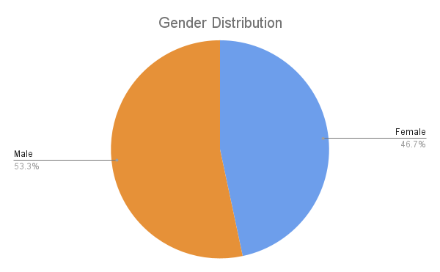
We found an equal distribution of two genders, male and female. We did not note any other genders during our interviews.

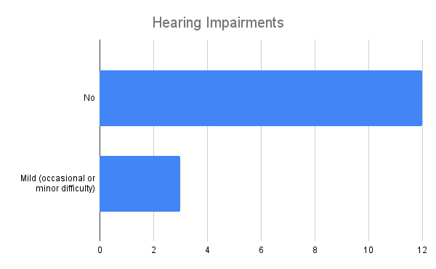
Generally most participants did not have any hearing impairments. However, some participants noted mild difficulty in hearing, although the reason is not specified.

4.2 Tool Familiarity
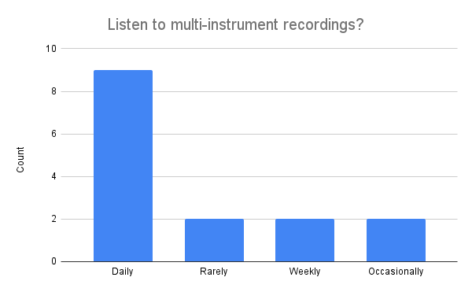
We observed that most participants listened to some sort of audio daily, and then the rest of the intervals were equally distributed. During the in-person interviews, we found that generally, this audio was music.
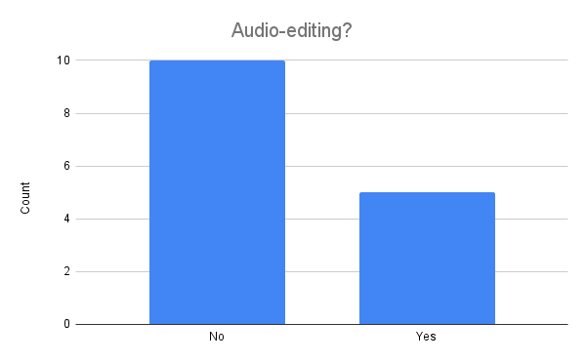
We observed that many users have not used any editing or mixing software, but some users did mention using software such as Audacity. We did not observe any commercial use of mixers or other advanced hardware.

4.3 Interface preference
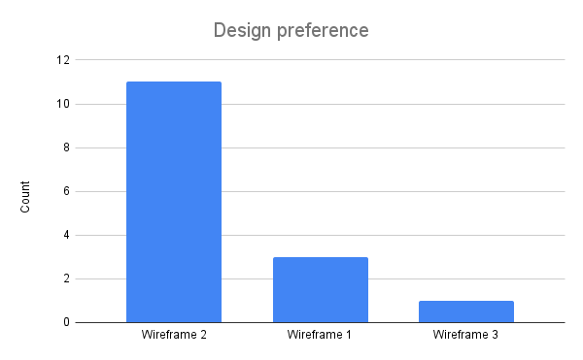
Most users preferred wireframe 2, which uses vertical sliders, over the other two options. We will discuss the user justifications in the next section, but we found the similarity between wireframe 2 and existing audio mixing hardware to be too high to ignore.

4.4 Usability and Design Insights
Throughout our interviews and in the responses collected online, we noted that most participants mentioned the simplicity of the volume control, mute toggle, and audio uploading. Many users found that the other two wireframes were too abstract or less functional than the vertical sliders. We also noted that many users did have some mental model of mixing technology, specifically tools like GarageBand or Audacity, which use vertical sliders.

We also noted that most participants listen to some form of multi-faceted audio on a daily basis. This indicates that while users regularly consume audio, their engagement is primarily passive rather than creative. Many users also gave examples of where MUSE would be useful, such as boosting lecture recordings, building karaoke soundtracks, or boosting audiobooks.

MUSE User Study (Responses)

“I prefer Wireframe 2 because its individual vertical sliders offer more precise control, and the included Mute and Solo options are very useful. “

5. System Requirements
These requirements were derived from observed user preferences and comments during the study. They represent both functional system needs and non-functional (UI/UX) goals.

5.1 Functional Requirements

Functional Requirement | Description
Audio Upload | Users can upload audio files (e.g., MP3, WAV) from their device.
Source Separation | The system should separate the uploaded audio into distinct components such as vocals, instrumentals, and background layers.
Adjustable Controls | Users should be able to modify the levels of each separated component through the chosen interface (sliders, knobs, etc.).
Real-Time Preview | Users can preview changes to the mix before exporting the final version.
Export Function | Users can export or download the modified audio in a common file format.
Interface Variants | The system supports multiple input styles (horizontal sliders, vertical sliders, knobs) for comparison and user testing.
Accessibility Options | The interface accommodates users with hearing sensitivities or accessibility needs (e.g., visual indicators, adjustable contrast).

5.2 UI/UX Requirements

UX / Non-Functional Requirement | Description
Usability | The interface should be intuitive and easy to use, even for users with no prior audio editing experience.
Efficiency | The system should process and preview audio adjustments quickly with minimal delay.
Reliability | The tool should handle standard audio file types without crashes or data loss.
Accessibility | The design should support users with varying hearing abilities and visual needs.
Transparency | The system should clearly communicate which parts of the audio are being modified or enhanced.
Aesthetic Simplicity | The interface should maintain a clean and uncluttered layout that emphasizes the key controls.
Fairness and Inclusivity | The system should avoid bias toward any particular audio genre, voice type, or device setup.
Learnability | New users should be able to understand basic functions without needing a tutorial.

